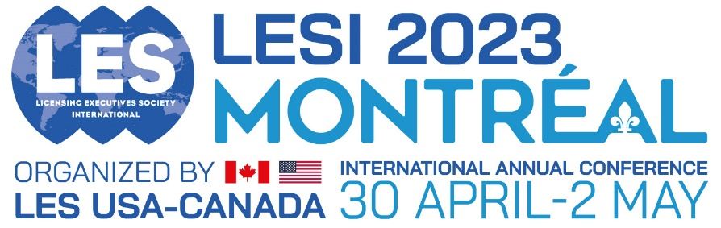

Call for Proposals for LESI2023 - Concurrent Sessions

Concurrent sessions will last 90 mins with up to 4 speakers.

Please use all of the following headings to format your submission - delete all text in red before submitting

Concurrent Session title:

Concurrent Session overall summary (up to 350 words):

Suggested Moderator and/or Speakers (up to 4 speakers + moderator max):
Full Name, title, company and email address

Session Abstract for each speaker (up to 4) (Up to 350 words):

_______
Other information:

Related Papers or articles previously published (if relevant):

Related Sessions at previously LES meetings (if relevant):

