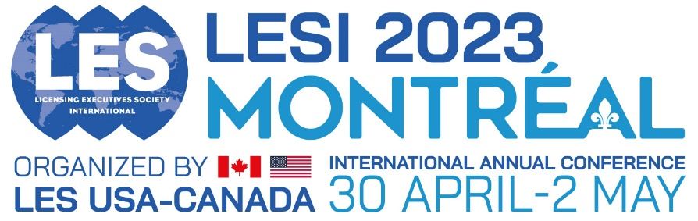

Call for proposals - Individual

For an individual presentation the programme committee will allocate you a slot within a concurrent session of a similar topic. The full session will last approx. 90 mins with each individual presentation lasting 20 mins

Please use all the following headings to format your submission- delete all text in red before submitting

Speaker presentation title:

Speakers
Full Name, title, company and email address

Session Abstract (Up to 350 words):

_______
Other information:

Related Papers or articles previously published (if relevant):

Related Sessions at previously LES meetings (if relevant):

